Yusuf Shaikh(816921177)

Lab6 Final Project 4x4 KeyPad

CompE 470L

04/26/2017

Intro:

For my final project I decided to connect a 4x4 keypad to the I/O pins of the FPGA. From here as each button was pressed the info correlating to that button. This was very similar to the project done in 375 with the Keypad; however, the small difference of switching a microcontroller (AVR) to a FPGA created great complications. The largest complication that this created was in the AVR we did not have to set Pins as PullDowns, Pullups, Outputs or inputs, we simply checked if a pin was high or low. In the FPGA we had set each PIN as a pullup or pulldown, and within the Verilog code set those variables as inputs or outputs.

Hardware & PIN Setup:

After doing research on the 4x4 keypad, I figured out how the system actually works. There are a total of 8 Pins on the 4x4 keypad. The first 4 pins represent the *4 ROWS* of the keypad and the last 4 pins represent the *4 ROWS*. How the system actually works is that the Columns act like OUTPUTS (TX) from the FPGA. Essentially the FPGA will send the Pins connected to the Columns a 1 (3.3V). The Rows act like INPUTS(RX), So if a Column has a high value and a button a row is pressed will flow through the button and back into the board. The way it does this is that the ROWS are to be set as Pulldowns (Set to ground) there by dragging the voltage to ground and back into the FPGA. The Diagram below shows it in more detail.

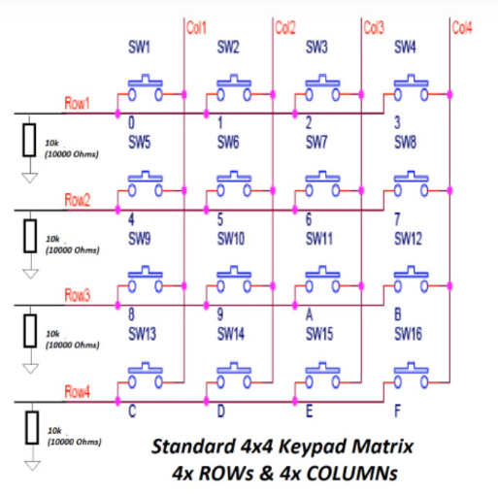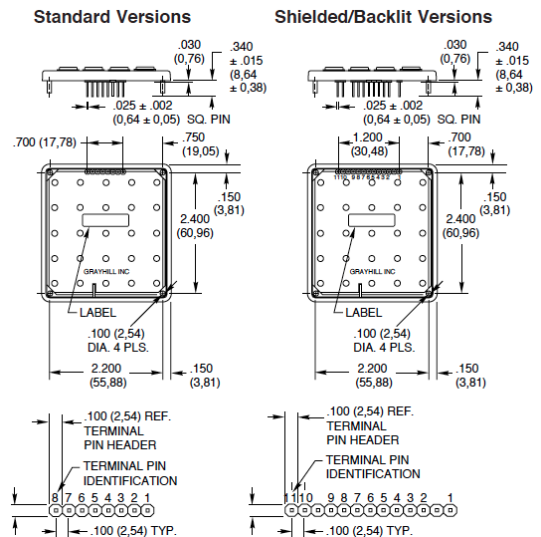

Code Setup:

So now that the Pins were setup accordingly the next issue was recognizing which button was pressed. For testing purposes I setup the F_LED lights so All the Columns were outputted to High and when I pressed a certain row that F_LED correspondingly turned on.

However it would not recognize what specific button was pressed. The solution to this issue was to quickly alter through ach column sending it a High value and then going to the next column. As this was happening if any button was pressed, it would recognize for that column and that row and ground the voltage back to the FPGA. This then created a circuit loop for that specific button and column.

To get the output value, I created a case statement to check which rows or columns were high. {Row1,Row2,Row3,Row4,Column1,Column2,Column3,Coulmn4} and then based on this I assigned the 7 Segment LED a certain output value.

Diagrams:

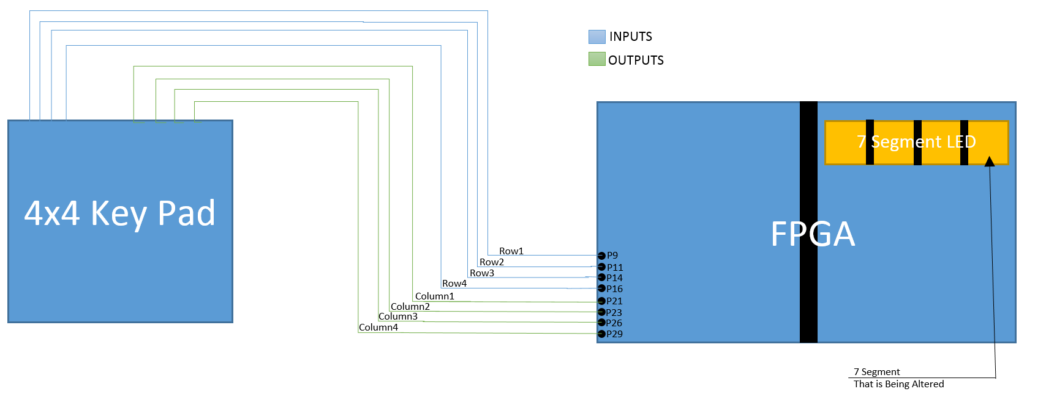

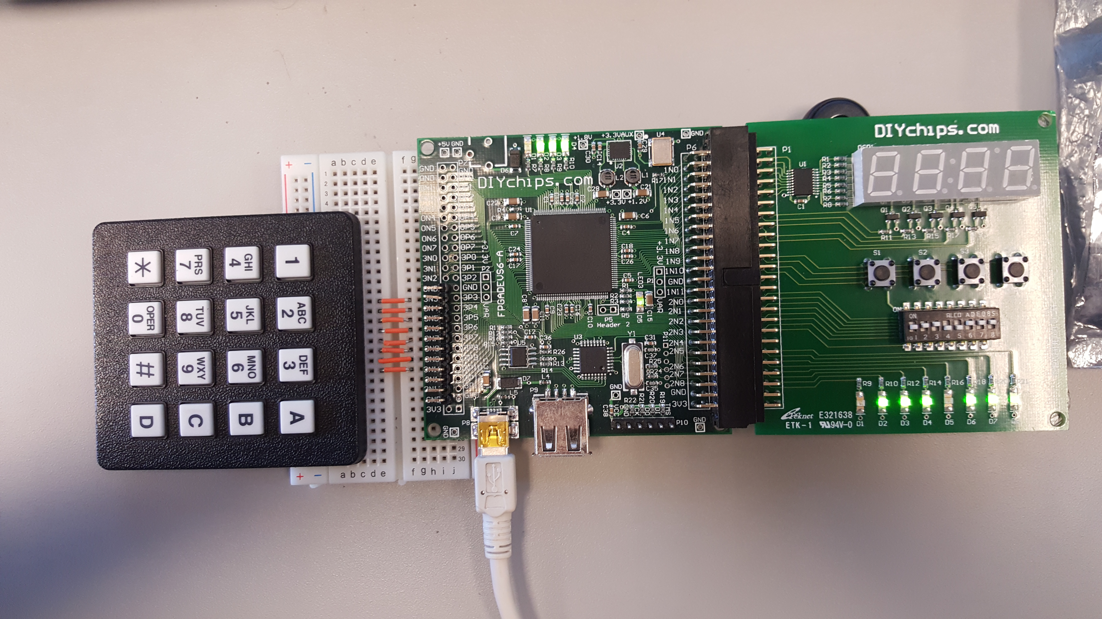

Code:

UCF Adjustments:

NET "Row1" LOC = P9 | PULLDOWN;//3_N3

NET "Row2" LOC = P11 | PULLDOWN;

NET "Row3" LOC = P14 | PULLDOWN;

NET "Row4" LOC = P16 | PULLDOWN;

NET "Column1" LOC = P21;// | PULLUP;

NET "Column2" LOC = P23; // | PULLUP;

NET "Column3" LOC = P26; // | PULLUP;

NET "Column4" LOC = P29; //| PULLUP; //3_N10

`timescale 1ns / 1ps

//////////////////////////////////////////////////////////////////////////////////

// Company:

// Engineer:

//

// Create Date: 23:16:57 03/14/2017

// Design Name:

// Module Name: DIgitalClock

// Project Name:

// Target Devices:

// Tool versions:

// Description:

//

// Dependencies:

//

// Revision:

// Revision 0.01 - File Created

// Additional Comments:

//

//////////////////////////////////////////////////////////////////////////////////

module FinalProject(input M_CLOCK, // FPGA clock

input Row1,Row2,Row3,Row4,

output reg Column1,Column2,Column3,Column4,

input [3:0] IO_PB,

output [3:0] F_LED, // FPGA LEDs

output [7:0] IO_LED, // IO Board LEDs

output reg [3:0] IO_SSEGD, // IO Board Seven Segment Digits

output reg [7:0] IO_SSEG, // 7=dp, 6=g, 5=f,4=e, 3=d,2=c,1=b, 0=a

output IO_SSEG_COL,

output DEC_POINT);

assign IO_SSEG_COL = 1; // deactivate the colon displays

assign F_LED = ~IO_PB;

assign DEC_POINT = 1'b1;

assign IO_LED = 8'b00000000;

wire FlagCheck = 1'b0;

reg [7:0] AllPins;

reg [31:0] ColumnCounter = 0;

reg [31:0] DisplayCounter = 0;

reg [1:0] ColumnState = 0;

reg Columns = 0;

reg DisplayResults = 0;

reg FLAGG = 1'b0;

reg checkflag = 1'b0;

reg [7:0] SEG1;

//**************CLOCK RATE***************************//

always @(posedge M_CLOCK) begin

ColumnCounter <= ColumnCounter + 1;

DisplayCounter <= DisplayCounter + 1;

if (ColumnCounter == 1850000) begin //22000 208000

Columns <= ~Columns;

ColumnCounter <= 0;

end

if (DisplayCounter == 125000) begin //34500000

DisplayResults <= ~DisplayResults;

DisplayCounter <= 0;

end

end

//***************************************************//

//***************Going Through Columns**************//

always @(posedge Columns) begin // THE SEGMENTS

case(ColumnState)

0: begin

{Column1,Column2,Column3,Column4} <= 4'b1000;

case ({Row1,Row2,Row3,Row4})

4'b1000: begin

AllPins <= ({Row1,Row2,Row3,Row4,Column1,Column2,Column3,Column4});

FLAGG <= 1'b1;

checkflag = 1'b1;

end

4'b0100: begin

AllPins <= ({Row1,Row2,Row3,Row4,Column1,Column2,Column3,Column4});

FLAGG <= 1'b1;

checkflag = 1'b1;

end

4'b0010: begin

AllPins <= ({Row1,Row2,Row3,Row4,Column1,Column2,Column3,Column4});

FLAGG <= 1'b1;

checkflag = 1'b1;

end

4'b0001: begin

AllPins <= ({Row1,Row2,Row3,Row4,Column1,Column2,Column3,Column4});

FLAGG <= 1'b1;

checkflag = 1'b1;

end

default: begin

FLAGG <= 1'b0;

ColumnState <= 1;

end

endcase

end

1: begin

{Column1,Column2,Column3,Column4} <= 4'b0100;

case ({Row1,Row2,Row3,Row4})

4'b1000: begin

AllPins <= ({Row1,Row2,Row3,Row4,Column1,Column2,Column3,Column4});

FLAGG <= 1'b1;

checkflag = 1'b1;

end

4'b0100: begin

AllPins <= ({Row1,Row2,Row3,Row4,Column1,Column2,Column3,Column4});

FLAGG <= 1'b1;

checkflag = 1'b1;

end

4'b0010: begin

AllPins <= ({Row1,Row2,Row3,Row4,Column1,Column2,Column3,Column4});

FLAGG <= 1'b1;

checkflag = 1'b1;

end

4'b0001: begin

AllPins <= ({Row1,Row2,Row3,Row4,Column1,Column2,Column3,Column4});

FLAGG <= 1'b1;

checkflag = 1'b1;

end

default: begin

FLAGG <= 1'b0;

ColumnState <= 2;

end

endcase

end

2: begin

{Column1,Column2,Column3,Column4} <= 4'b0010;

case ({Row1,Row2,Row3,Row4})

4'b1000: begin

AllPins <= ({Row1,Row2,Row3,Row4,Column1,Column2,Column3,Column4});

FLAGG <= 1'b1;

checkflag = 1'b1;

end

4'b0100: begin

AllPins <= ({Row1,Row2,Row3,Row4,Column1,Column2,Column3,Column4});

FLAGG <= 1'b1;

checkflag = 1'b1;

end

4'b0010: begin

AllPins <= ({Row1,Row2,Row3,Row4,Column1,Column2,Column3,Column4});

FLAGG <= 1'b1;

checkflag = 1'b1;

end

4'b0001: begin

AllPins <= ({Row1,Row2,Row3,Row4,Column1,Column2,Column3,Column4});

FLAGG <= 1'b1;

checkflag = 1'b1;

end

default: begin

FLAGG <= 1'b0;

ColumnState <= 3;

end

endcase

end

3: begin

{Column1,Column2,Column3,Column4} <= 4'b0001;

case ({Row1,Row2,Row3,Row4})

4'b1000: begin

AllPins <= ({Row1,Row2,Row3,Row4,Column1,Column2,Column3,Column4});

FLAGG <= 1'b1;

checkflag = 1'b1;

end

4'b0100: begin

AllPins <= ({Row1,Row2,Row3,Row4,Column1,Column2,Column3,Column4});

FLAGG <= 1'b1;

checkflag = 1'b1;

end

4'b0010: begin

AllPins <= ({Row1,Row2,Row3,Row4,Column1,Column2,Column3,Column4});

FLAGG <= 1'b1;

checkflag = 1'b1;

end

4'b0001: begin

AllPins <= ({Row1,Row2,Row3,Row4,Column1,Column2,Column3,Column4});

FLAGG <= 1'b1;

checkflag = 1'b1;

end

default: begin

FLAGG <= 1'b0;

ColumnState <= 0;

end

endcase

end

default: begin

ColumnState <= 0;

end

endcase

end

//***************************************************//

//******************Getting the Value Number********//

//***************************************************//

always @(FLAGG) begin

case (AllPins)

8'b10001000: begin // Row1 Column1

SEG1 <= {DEC_POINT, 7'b1111001}; //1

end

8'b10000100: begin //Row1 Column2

SEG1 <= {DEC_POINT, 7'b0100100}; //2

end

8'b10000010: begin //Row1 Column3

SEG1 <= {DEC_POINT, 7'b0110000}; //3

end

8'b10000001: begin //Row1 Column4

SEG1 <= {DEC_POINT, 7'b0001000}; //A

end

///

8'b01001000: begin // Row2 Column1

SEG1 <= {DEC_POINT, 7'b0011001}; //4

end

8'b01000100: begin //Row2 Column2

SEG1 <= {DEC_POINT, 7'b0010010}; //5

end

8'b01000010: begin //Row2 Column3

SEG1 <= {DEC_POINT, 7'b0000010}; //6

end

8'b01000001: begin //Row2 Column4

SEG1 <= {DEC_POINT, 7'b0000011}; //b

end

///

8'b00101000: begin // Row3 Column1

SEG1 <= {DEC_POINT, 7'b1111000}; //7

end

8'b00100100: begin //Row3 Column2

SEG1 <= {DEC_POINT, 7'b0000000}; //8

end

8'b00100010: begin //Row3 Column3

SEG1 <= {DEC_POINT, 7'b0011000}; //9

end

8'b00100001: begin //Row3 Column4

SEG1 <= {DEC_POINT, 7'b1000110}; //C

end

///

8'b00011000: begin // Row4 Column1

SEG1 <= {DEC_POINT, 7'b1000000}; //* = 0

end

8'b00010100: begin //Row4 Column2

SEG1 <= {DEC_POINT, 7'b1000000}; // 0

end

8'b00010010: begin //Row4 Column3

SEG1 <= {DEC_POINT, 7'b1000000}; //# = 0

end

8'b00010001: begin //Row4 Column4

SEG1 <= {DEC_POINT, 7'b0100001}; // d

end

default: begin

if (checkflag == 0)

SEG1 <= {DEC_POINT, 7'b00000000};

else

SEG1 <= SEG1;

end

endcase

end

always @(posedge DisplayResults) begin // THE SEGMENTS

IO_SSEGD <= 4'b0111;

IO_SSEG <= SEG1;

end

endmodule